

**WOLDIA UNIVERSITY**

**FACULTY OF TECHNOLOGY**

**DEPARTMENT OF COMPUTER SCIENCE**

**Computer Vision and Image Processing Project on Ethiopian Car Plate Number Recognition System**

**Section One Group 10**

**Submitted to: Instructor Sebahadin Nasir (MSc)**

**January 30, 2019**

**Woldia, Ethiopia**

**Ethiopian Car Plate Number Recognition System**

**By Group 10 Section 1:**

**Name ID Email**

1. **Daniel Tefera ----------FOT(R)1699/08………. danieltefera14@gmail.com**
2. **Biruk Debebe ----------FOT(R)1665/08………. birukdebebe432@gmail.com**
3. **Alelign Kebede -------- FOT(R)1649/08………. alexof211@gmail.com**
4. **Kasim Misganaw ------FOT(R)1806/08…….….kassimisge@gmail.com**
5. **Ayalnesh Tsehaye -----FOT(R)1667/08………..ayaltseyeshi@gmail.com**
6. **Habtam Dessie -------- FOT(R)1778/08………...habtamdessie1@gmail.com**

**Contact person**

Name: Daniel Tefera

Email: [danieltefera14@gmail.com](mailto:danieltefera14@gmail.com)

Phone number: 0919319791

Advisor: Sebahadin Nasir (MSc)

**Table Contents**

**1.** **Introduction** 3

**2.** **Problem domain description** 3

**3.** **Scope of the project** 4

**4.** **Objective of the project** 4

**4.1** **General objective** 4

**4.2** **Specific objective** 4

**5.** **Data Collection** 5

**5.1** **Image collection methods** 5

**5.2** **Image set description** 5

**5.3** **Image acquisition parameters** 5

**6.** **Architecture of the designed CVIP system** 6

**7.** **Summary** 7

**8.** **Reference** 7

# **Introduction**

Now a days most system are changed into automated system to make easier to use and secured. But, Ethiopian car plate are identified manually for the purpose of security especially related to traffic system. The traffic police may miss the car if the speed of the car is too high. So, to control those cars that make a crime can be easily cached by this system. In Ethiopia there are many cars with their own unique car plate. Each car plate have their own description for instance the nine Ethiopian nation and nationality and the two city administration have their own unique ID like for Amhara AM, for Tigray TG, for Oromia OR, for Benshangul BN, for Harar HR, for Debub People DB, for Gambela GM, for Affar AF, for Somalli SO, for Diredawa DD and for Addis Abeba AA and also there are many other like UN for United Nation in Ethiopia, DF for National defense of Ethiopia and many other with unique four or five digit numbers. So, by this proposed system any in our domain car can be identified easily.

# **Problem domain description**

Today Ethiopian national security force and Ethiopian police commission uses manual system to track the wanted car. Since it is manual it have many problems like:

* Time consuming – here to identify one’s wanted car it takes too much time when we compared with this system.
* Improper use of resource – it takes many resources like human power, time, communication cost for a simple identification of the wanted car plate.
* Lack of accuracy – the current manual system is error prone, means the police man may identify and arrest the innocent person car.
* Lack of satisfaction – customers actually the “surveillance”may be innocent but, due to it is bored process to identify the exact person’s car and since it is time consuming and inaccurateness may not be satisfied.
* Lack of speed – the exact crime maker or the wanted person may not be identified in a short period of time with his or her own car.

# **Scope of the project**

The scope of this project is:

* Loading the image from their source
* Preprocessing the loaded image
* Segmenting the preprocessed image
* Loading the segmented image
* Saving the features of the images
* Loading the saved features
* Training the system
* Recognizing and interpreting the system

# **Objective of the project**

## **General objective**

The general objective of this project is to develop automated Ethiopian car plate recognition system.

## **Specific objective**

The specific objective of this project is:

* To collect requirements.
* To study the existing system.
* To study the analysis.
* To design the interface.
* To implement it
* To test it

# **Data Collection**

## **Image collection methods**

We use Random collection method for collecting different car plate images like Amhara AM, Oromia OR, Ethiopia ET, and Addis Ababa AA and also there are many other like UN for United Nation in Ethiopia for the input of this project. Simply we capture car plates in our surrounding whether it is Bajaj, Sino truck, Landcruser…

## **Image set description**

|  |  |  |  |
| --- | --- | --- | --- |
| **Image class** | **Number of image** | **Image extension** | **Spatial resolution** |
| AM (Amhara) | 17 | .jpg | 70 |
| AA (Addis Abeba) | 30 | .jpg | 70 |
| ET (Ethiopia) | 58 | .jpg | 70 |
| UN (United Nation) | 2 | .jpg | 70 |

Table 1 Set of image description

## **Image acquisition parameters**

To collect the car plate images we used our smart phones due to this our image have some quality problem due to different parameters like: [1]

* **Motion blur/blur due to subject movement-**When the car is moving and the shutter speed that we selected/or the camera has selected does not freeze the movement, then the resulting photograph would appear blurred.
* **Improper holding of camera-**Our smart phone camera was shaking due to improper holding when we capture the car plates. Actually this is comes from lack of experience on photographing.
* **Shake due to internal vibrations-**When we press the button, a vibration passes along the lens which causes a slight movement in the camera.
* **Dirty lens-** Mist, greasy smears, smudges in front of our smart phone camera lens give us blurry photos. Since our smart phone was used for a long period of time.
* **Focus-** We were focusing on a wrong area thenour image results becomes blurred.

# **Architecture of the designed CVIP system**

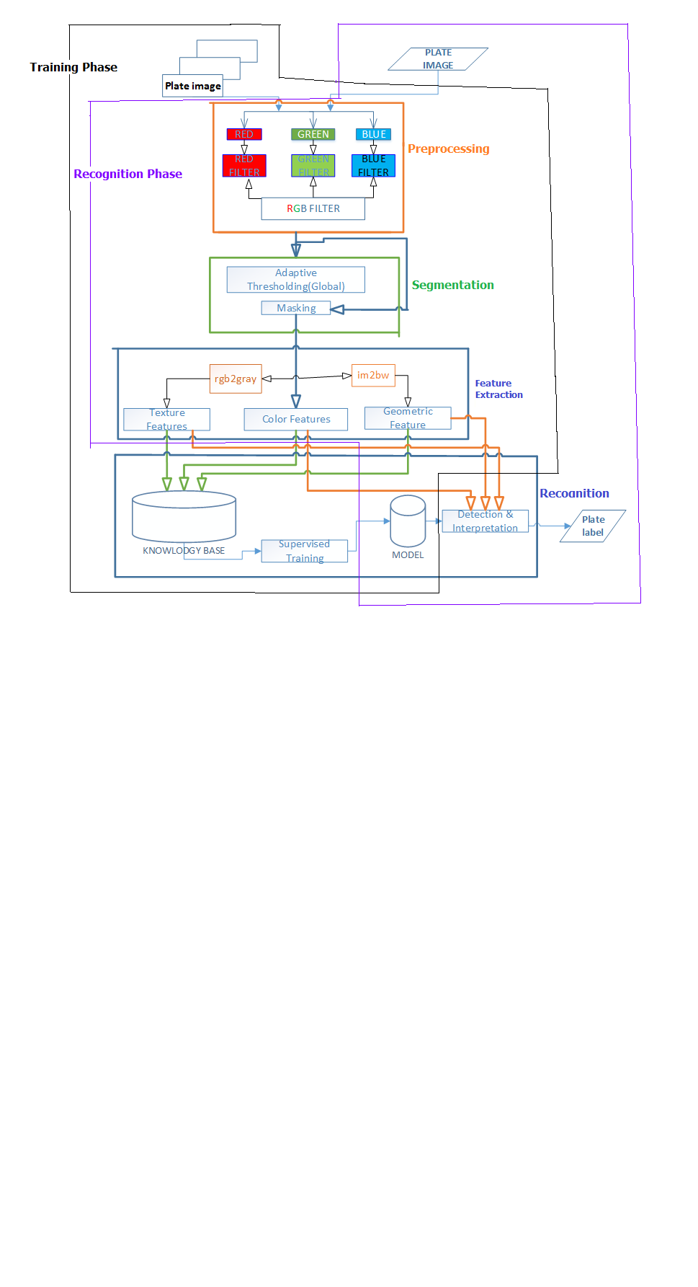

# **Summary**

The main objective of this project is to develop automated Ethiopian car plate recognition system to minimize the risk and error that appear in Ethiopian traffic police system as well as in Ethiopian national defense to identify one’s car using it’s car plate and also to minimize the time that takes to investigate and to identify one’s car using it’s car plate. In this system we used random selection method to collect car plate images and we used our smart phones to capture the car plates from the cars.During this project development we face many problemslike difficulties to get car plate images that are not appear here like Somalli (SO),Benshangul(BN) car plates, ….., disagreement to capture one’s own car plate from his or her car and the last but not the least that we face problem is lack of time to make this project strong enough since we have the final project as well as courses to be studied.

Finally after the completion of this project it is very useful for the sake of security in National security offices well as Ethiopian police commission to identify wanted person by his or her driving car. It saves computation time to identify or to recognize one’s car using its car plate and also it is accurate and secured.

# **Reference**

1. Sebahadin Nasir,” Image acquisition lecture noteson chapter 2” woldia university faculty of technology department of computer science, woldia Ethiopia, October, 2017.